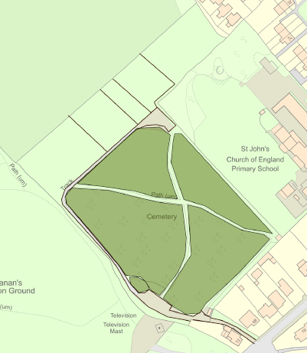

A

**Victoria Road**

Garden of Remembrance

HA

G

F

E

D

C

B

Natural Burial Ground

You are here

**Old Cemetery** (marked in darker green)

Section A: rows A-Z, Aa- Ww

Section B: rows A-Z, Aa-Uu

Section C: rows A-R

Section D: rows A-Q

For further subsections contact the Clerk.

**New cemetery**

Section E: rows SS-AA and Z- A

Section F: rows BB-AA and Z- A

Sections G and H are A-Z.

**The Natural Burial Ground** is located at the furthest point from the entrance, through the archway.

Coleford Town Council is responsible for this cemetery. The Town Clerk can be contacted on 01594 832103, [ctcoffice@colefordtowncouncil.gov.uk](mailto:ctcoffice@colefordtowncouncil.gov.uk) or at

1, The Town House

Lords Hill Walk

Coleford, Glos.

GL16 8BD

Natural Burial Ground